CS 255 System Design Document Template

This template lays out all the different sections that you need to complete for Project Two. Each section has guidance to prompt your thinking. You will need to continually reference the interview transcript as you work to make sure that you are addressing your client’s needs. There is no required length for the final document. Instead the goal is to complete each section based on what your client’s needs are. Remove this note when you are finished, and replace all bracketed text with the relevant information.

UML Diagrams

UML Use Case Diagram
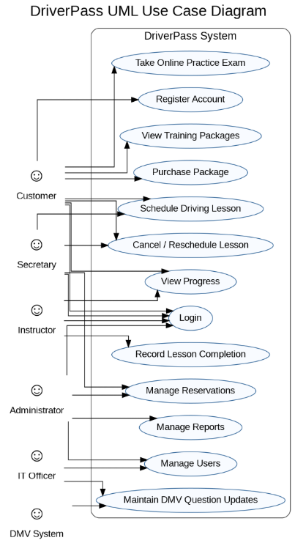

UML Activity Diagrams
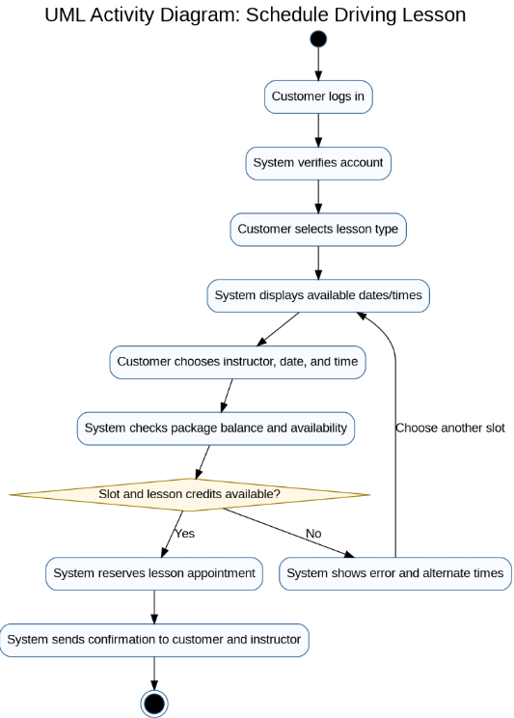
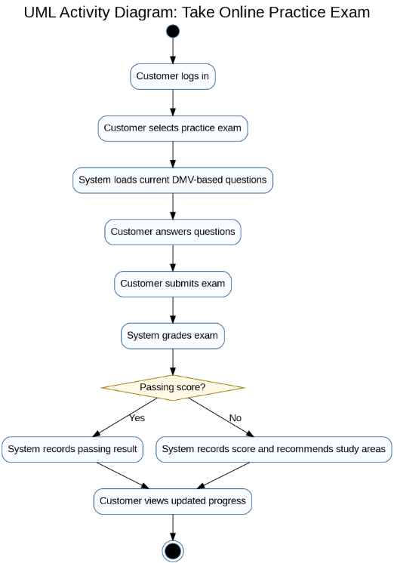

UML Sequence Diagram
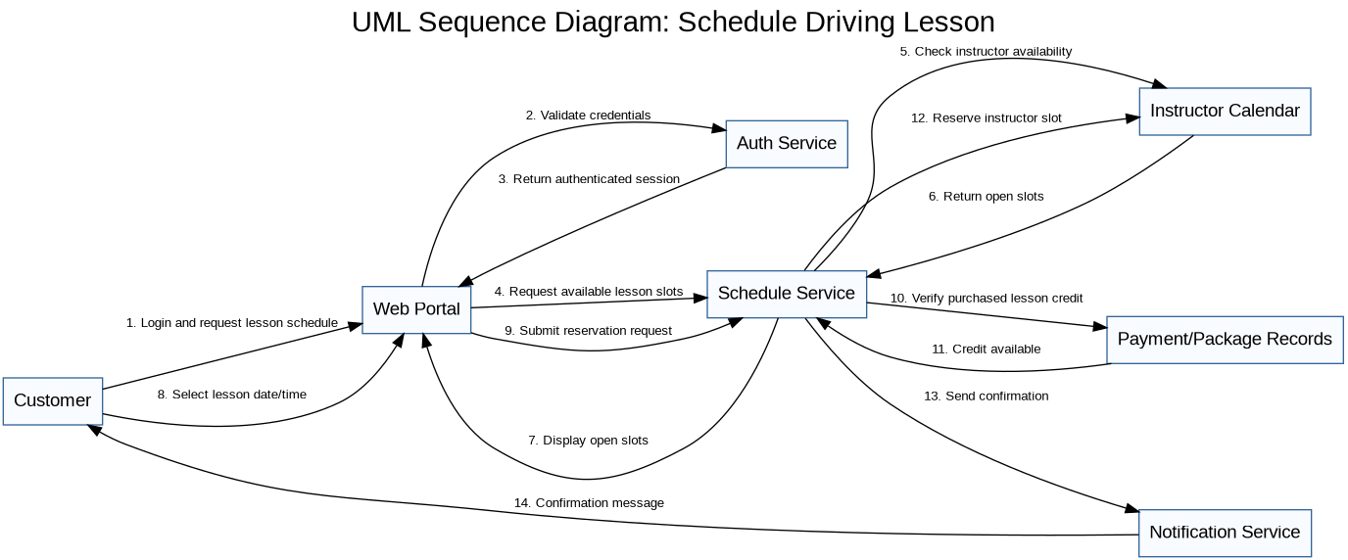

UML Class Diagram
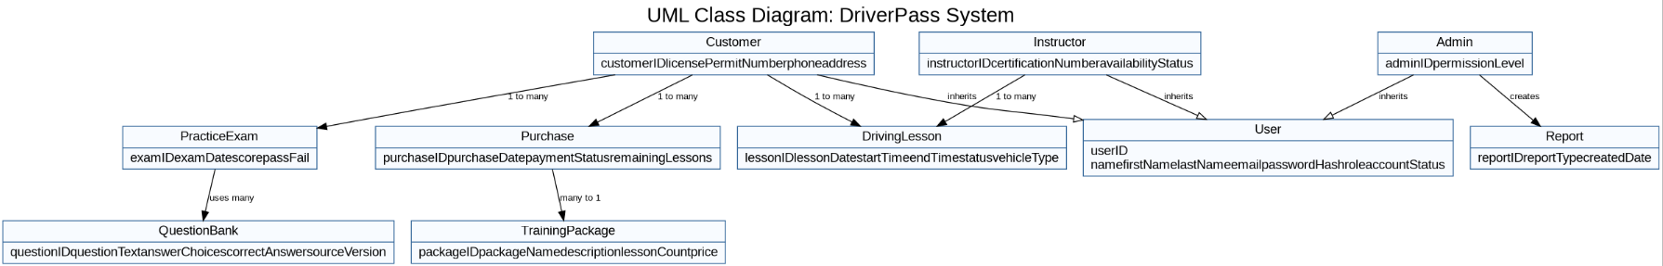

Technical Requirements
The DriverPass system will require reliable web-based software that allows customers, secretaries, instructors, administrators, and IT staff to access the system based on their roles. The system should include secure login, account management, package purchasing, online practice exams, scheduling tools, progress tracking, reporting, and DMV question updates. A database will be needed to store customer accounts, instructor information, lesson schedules, training packages, purchases, exam scores, and reports.
The system should run through a web browser and be hosted on a secure server or cloud platform so users can access it from different locations. Required tools include a relational database, secure authentication, backup and recovery tools, and administrative controls. The system should also support regular updates from DMV materials so practice exam questions stay current. Hardware needs include user computers or mobile devices, company workstations, secure servers, and reliable internet access.

